Law of Conservation of Mass

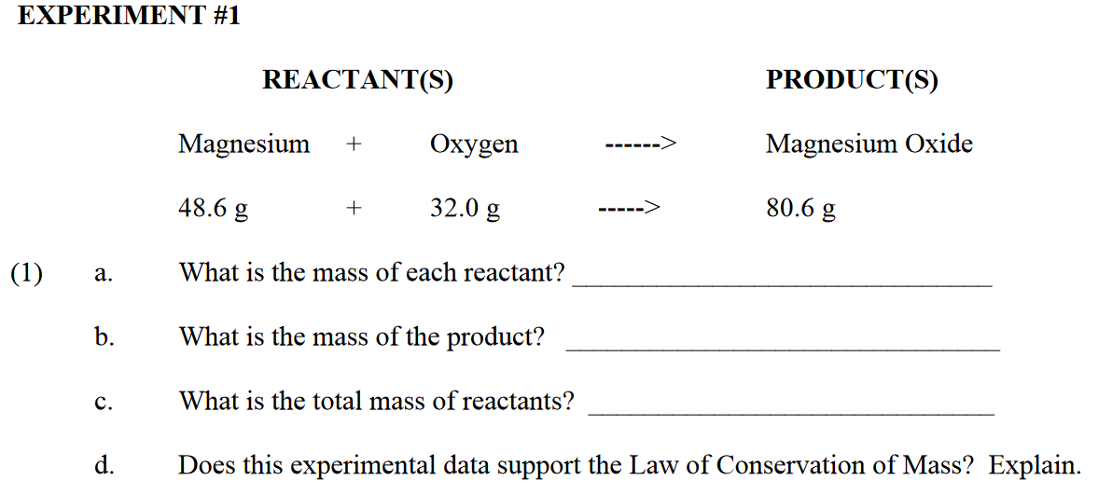

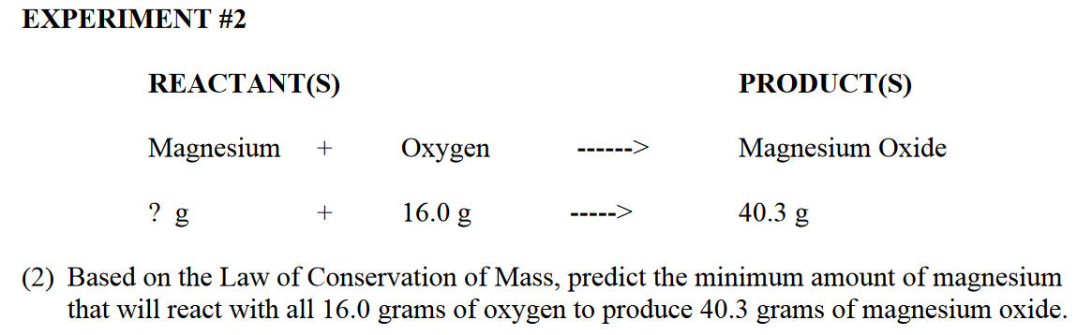

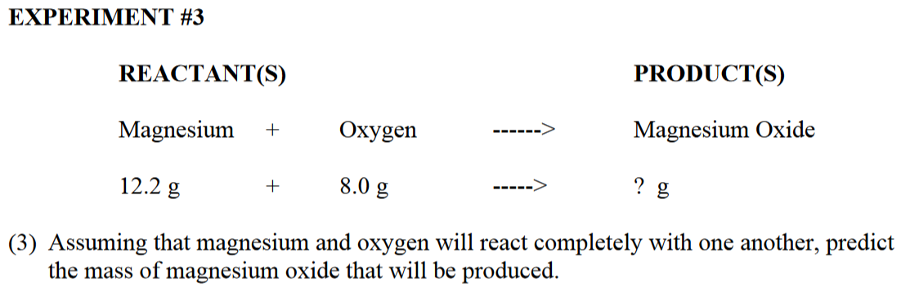
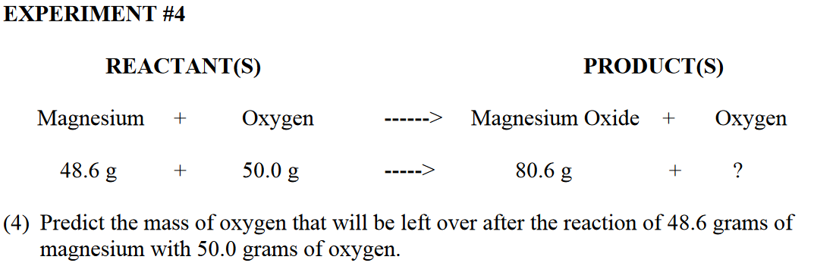

a. 4 grams of hydrogen reacts with some oxygen to make 36 grams of water. How much oxygen must have been used?

b. In a chemical reaction, a 150g baking soda mixture is heated which gives 87g of carbon dioxide gas and leaves behind a residue. What mass of solid residue will left?

c. How much oxygen is needed to produce 132g of carbon dioxide if 36g of carbon is used?

d. Does the following support the law of conservation of mass? Why?
Heating 10 grams of CaCO₃ produces 4.2 g of CO₂ and 5.5 g of CaO.

e. Hydrogen & oxygen react chemically to form water. How much water would form if 14.8 grams of hydrogen reacted with 34.8 grams of oxygen?

f. When ammonium nitrate (NH4NO3) explodes, the products are nitrogen, oxygen, & water. When 40 grams of ammonium nitrate explode, 14 grams of nitrogen and 8 grams of oxygen form. How many grams of water form?

g. A solid mass is mixed with 60g of a solution. A chemical reaction takes place. The mass of the resulting mixture is 75g. What was the mass of the solid mass?

h. If 115 g of a substance reacts with 84 g of another substance, what will be the mass of the products after the reaction?

i. A student adds 15g of baking soda to acetic acid in a beaker. A chemical reaction occurs and a gas is given off. After the reaction, the mass of the products remaining in the beaker is 23g. What was the mass of the acetic acid?

j. In the complete reaction of 22.99g of sodium with 35.45g of chloride, what mass of sodium chloride is formed?

k. A 12.2g of X react with a sample of Y to form 78.9g of XY. What is the mass of y that reacted?

l. A 10g sample of magnesium reacts with oxygen to form 16.6g of magnesium oxide. How many grams of oxygen reacted?

m. From a laboratory process designed to separate water into hydrogen and oxygen gas, a student collected a 10g of hydrogen and 79.4g of oxygen. How much water was originally involved in the process?

n. A 3.5kg iron shovel is left outside through the winter. The shovel, now orange with rust, is rediscovered in the spring. Its mass is 3.7kg. How much oxygen combined with the iron?

